Examples of concepts within Course Registration System

* **Method overloading**: Constructors are methods and the Student constructor in the Student class is overloaded. You can create a Student by providing all the parameters or only provide the firstName and lastName to create a Student with a default username and password

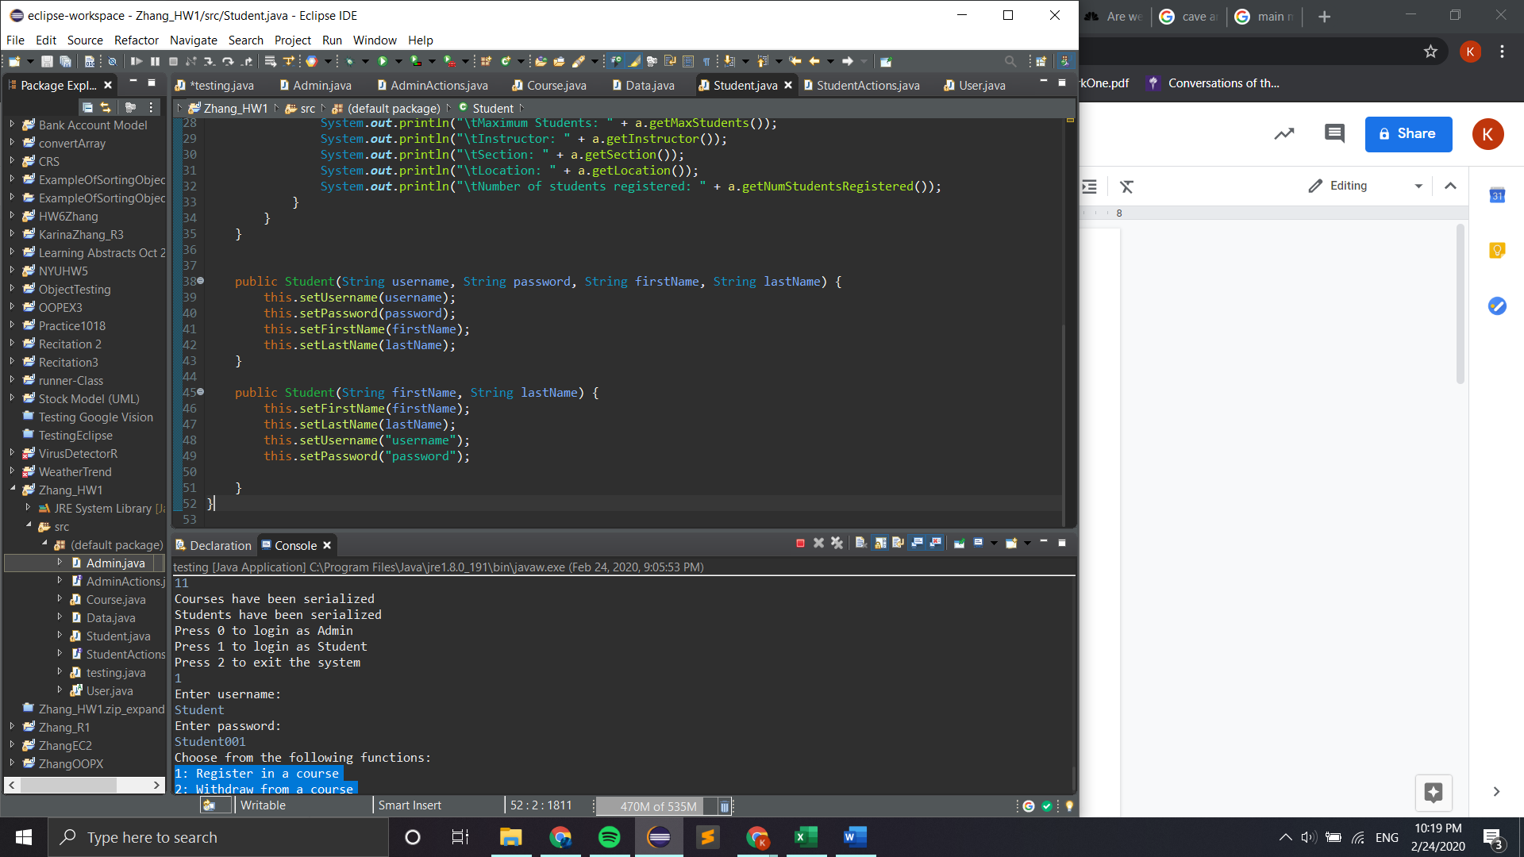

* **Method overriding**: The createCourse and deleteCourse methods exist in AdminActions as well as Admin.

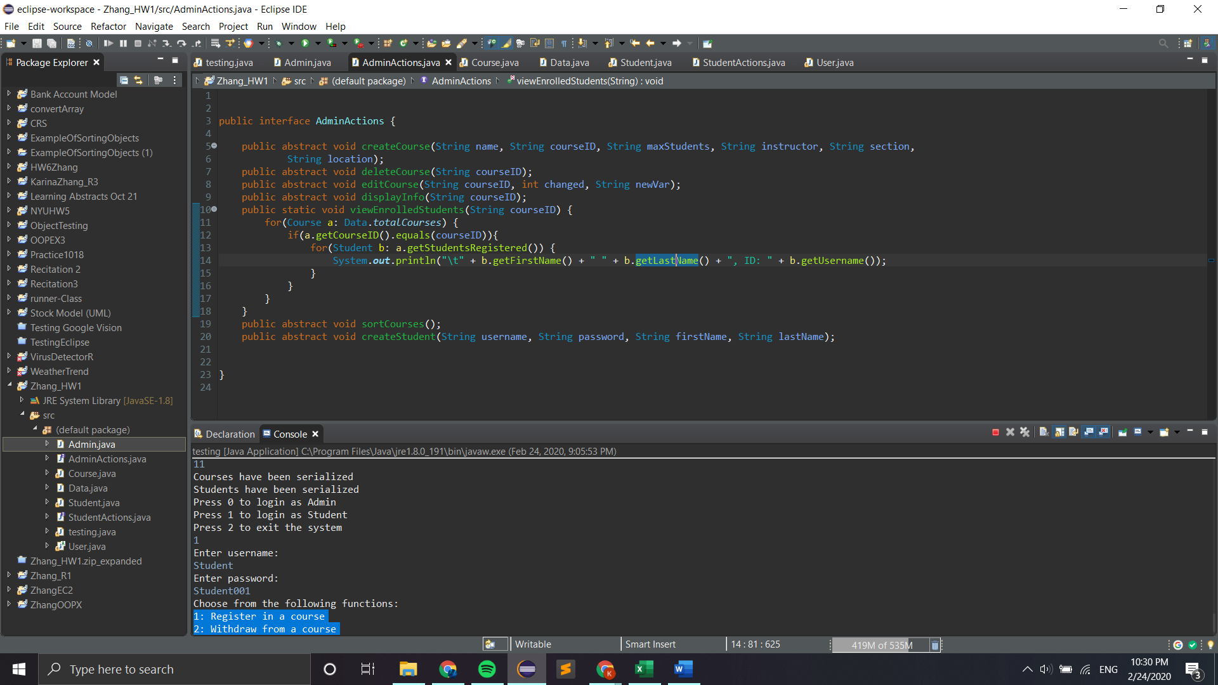

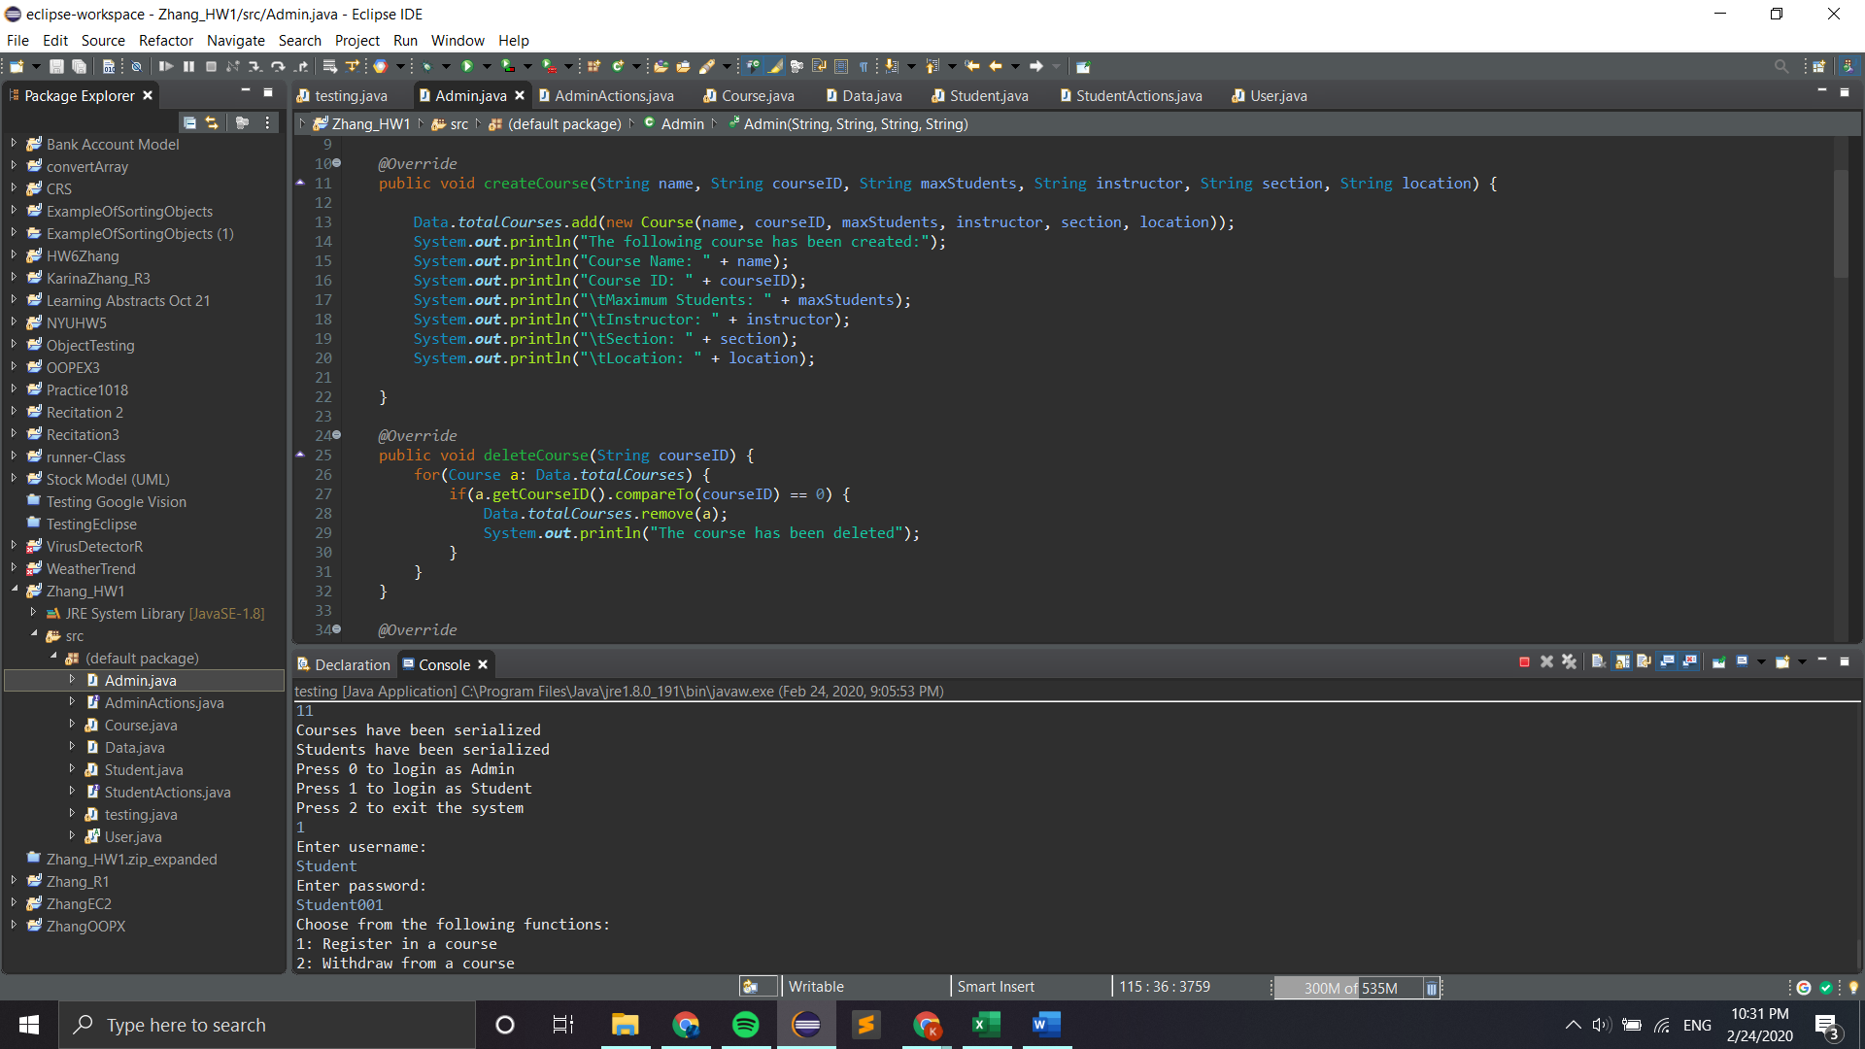



* **Abstract Class**: User is an abstract class

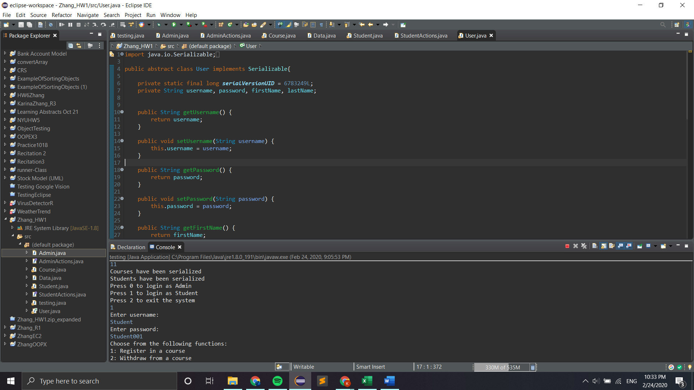

* **Inheritance**: Admin and Student both inherit from User

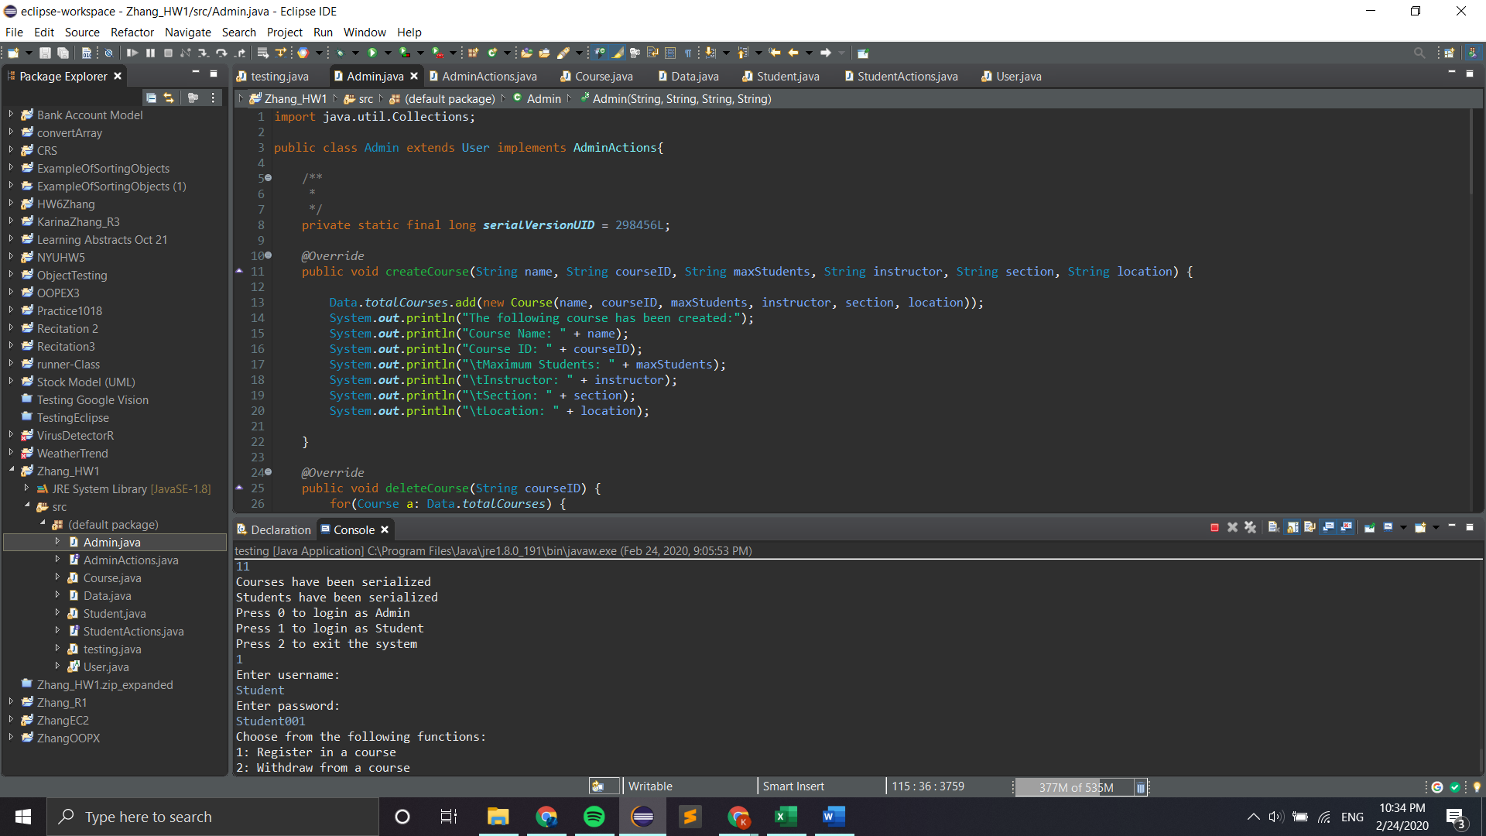

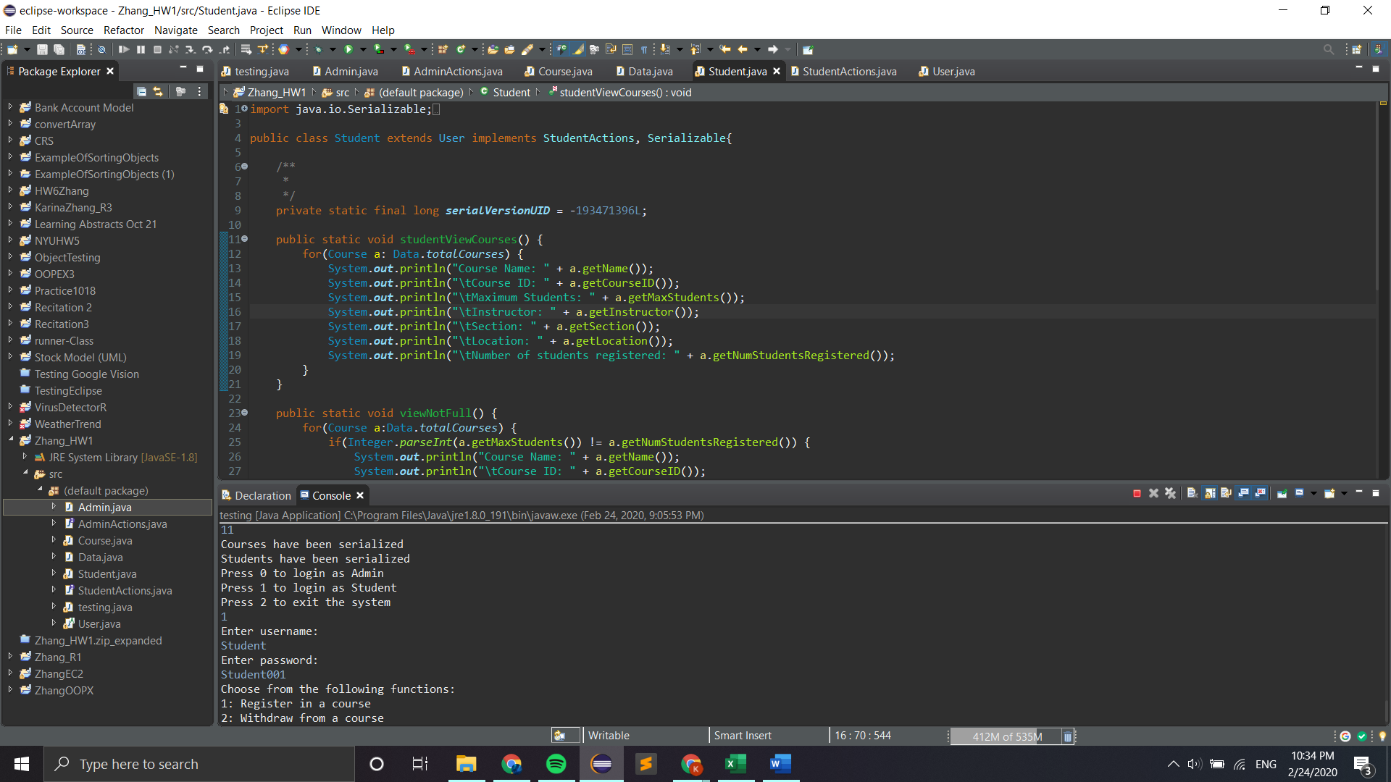

* **Polymorphism**: An Admin object is an Admin as well as a User



* **Encapsulation**: The attributes in the Course class are private and can only be accessed through getters and setters.

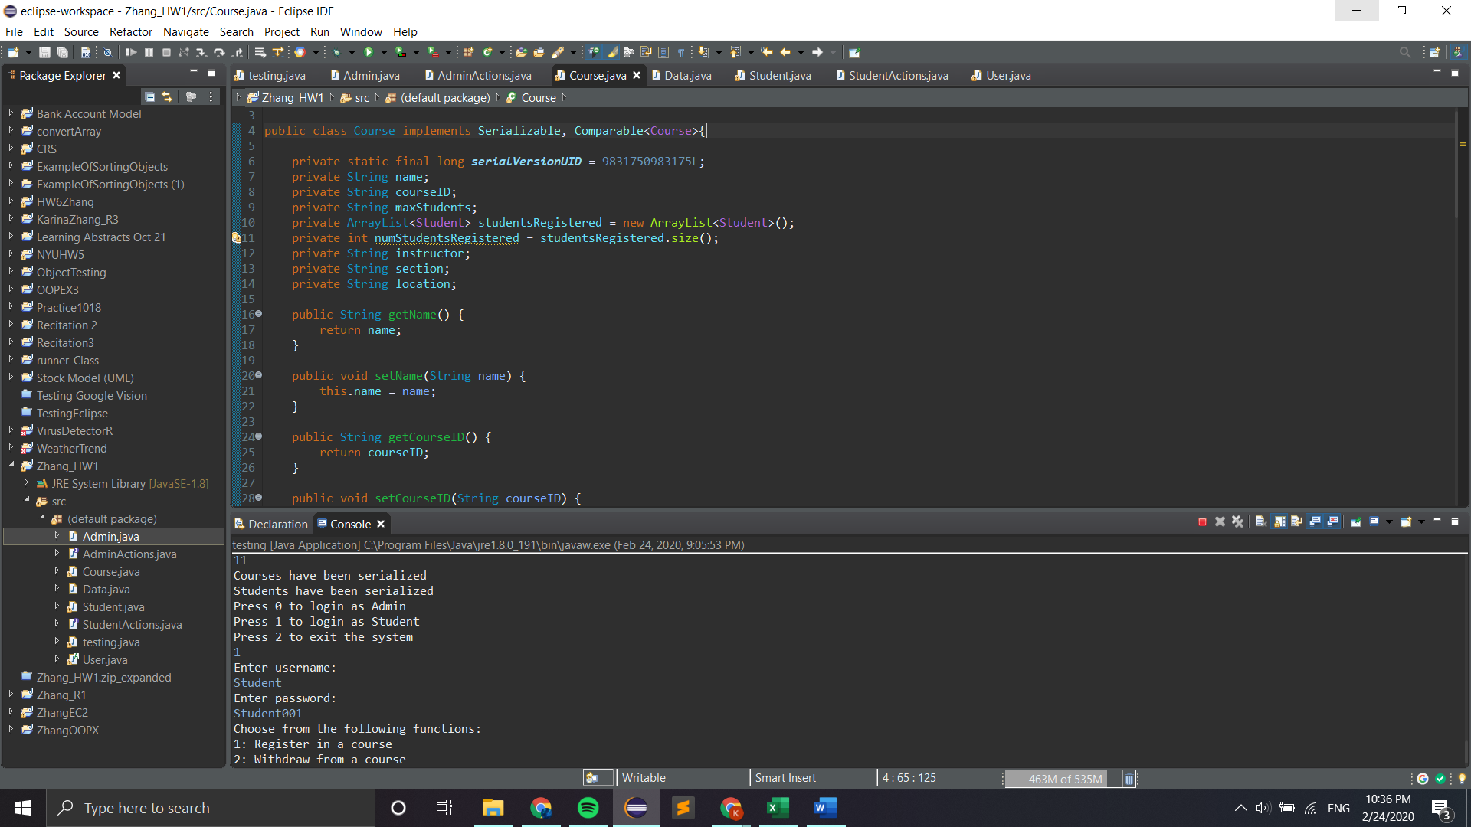

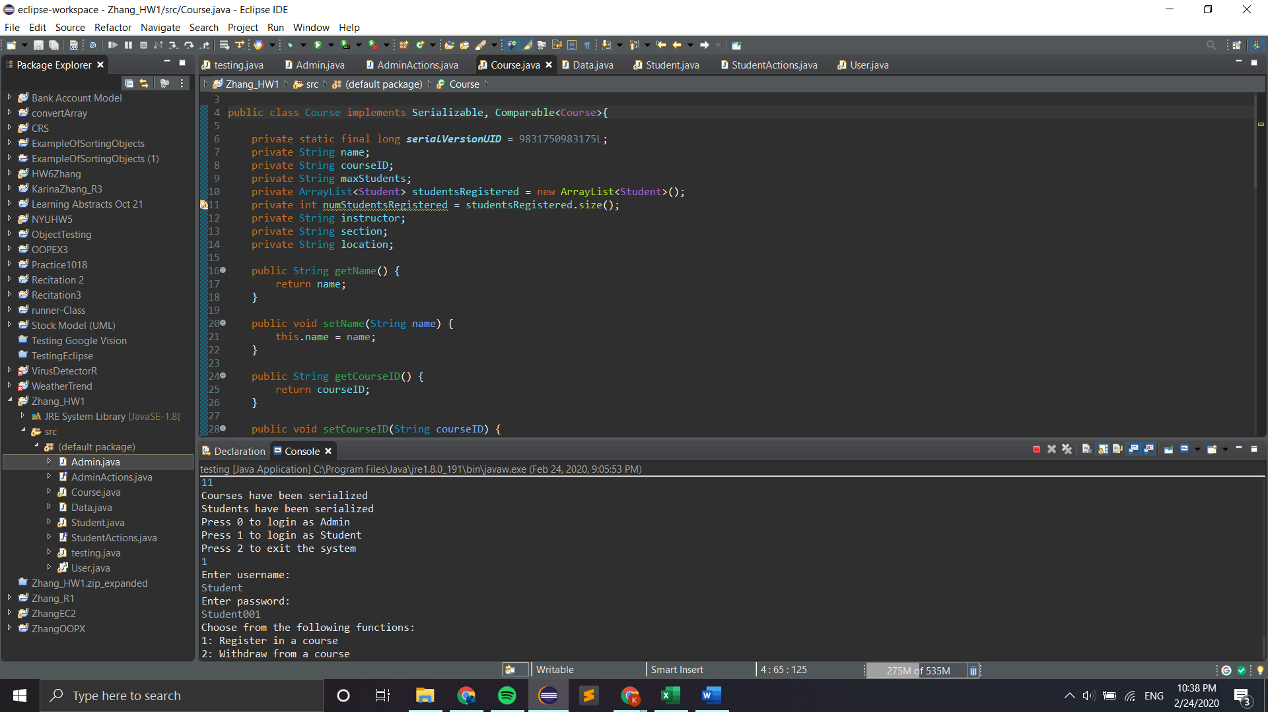

* **The concept of ADT**: List is an abstract data type and ArrayList is a concrete implementation of it. List is an interface

